NEW! 2023 Grafted Veggies from SuperNaturals
Grown by Grafted Growers

Tomato

Purple Zebra 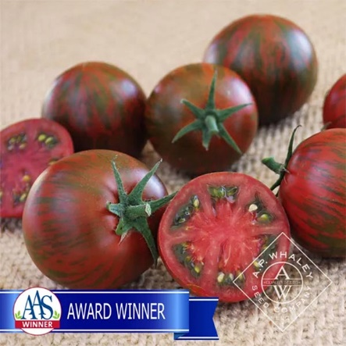
2021 AAS Award Winner. A fun new addition to striped tomatoes. Fruits are rich with complex flavors and moderately firm texture. Dark red fruits with green stripes and a deep mahogany red interior do not produce muddy coloration like other tomatoes of this type. Superb flavor. Excellent disease resistance including Late Blight. Good tolerance to cracking/splitting. Indeterminate, 80-85 days from transplant.
LABEL (With apologies to Gelett Burgess) If you’ve never grown a Purple Zebra, you’ll be surprised to see one. A taste treat fit for the Queen of Sheba, just wait till you grow, harvest and eat one! This All-America Selection is beautiful inside and out, with green-striped, dark red fruit that has deep mahogany interior. Indeterminate. 75 days from transplanting.

Darkstar 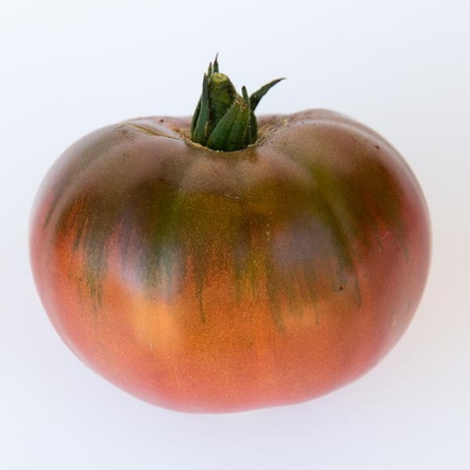
Indeterminate. A beautiful, rich, purple beefsteak with a wonderful tangy sweetness. Fruits weigh in at 8-10 ounces of perfect, made-for-a-BLT heaven. 75-80 days.
LABEL While Top Gun’s Darkstar is a fictional plane, this tomato is unbelievable, but definitely real. Gardener’s will appreciate the look and flavor of heirloom fruit (5-8 oz.), but the uniformity, disease resistance, and yield of a modern hybrid. It’s even late-blight resistant! Expect high yields from this galactic grower. Indeterminate. 75 days from transplanting.

Pepper

Sugar Rush Peach 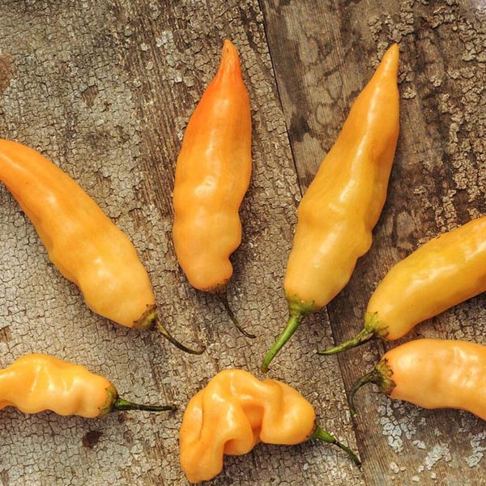
A sumptuous snacking pepper, Sugar Rush Peach is by far the most fun pepper to eat. The long, peach colored fruits are packed with loads of super sweet, tropical flavor, and the seeds bring a smokey, complex heat that when used together, creates a wild flavor experience unparalleled in any pepper we have tried. Especially good when roasted over an open flame, which bring out the fruitiness. This exciting new open-pollinated variety was bred by hot pepper prodigy Chris Fowler of Wales. Chris credits this amazing variety as being a happy accident, courtesy of adventurous pollinating insects buzzing between various varieties of capsicum baccatum, or Aji Peppers. The result: super early, high yields of these exquisite sweet hot peppers. 80-100 days.
LABEL It’s about time there’s a sugar rush that is actually healthy! The oblong, peach-colored peppers are loaded with super sweet, tropical flavor that’s paired with seeds that add a smoky, complex heat. The perfect ingredient for a fruity salsa, or to spice up a breakfast omelet. Dozens of fruit per plant! A tropical hottie that’s 4’-5’ tall. 85 days from transplanting.

Habanada 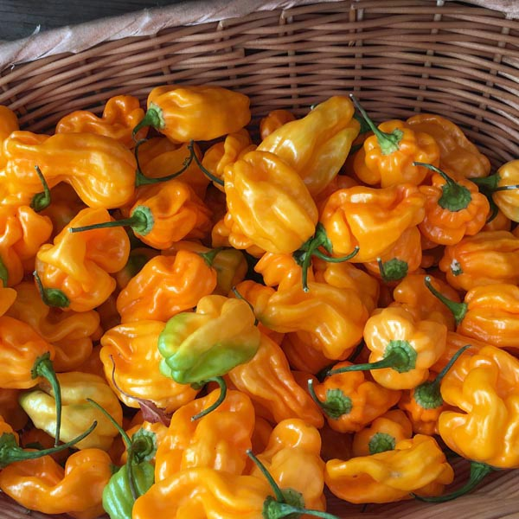
A new heatless habanero with irresistible tropical flavor, bred by Dr. Michael Mazourek of Cornell University. Excellent when seared, braised, roasted or raw, Habanada is a culinary jewel! Extremely productive and early. Can be used for chopping in the green stage, but we prefer to be patient and use them when they turn fully orange. 70 days for green fruits or 90 days from transplant for orange.
LABEL Even a hot pepper wuss can enjoy all of the fruity and floral notes of flavorful peppers without any of the scorching heat (even the seeds are sweet and add to the flavor), with the world’s first heatless habanero! Compact plants are great for small spaces or containers. Shiny, orange fruit is ready to harvest about 85 days from transplanting.

