What’s new in Mighty ‘Mato & Mighty Veggie Grafted Vegetables??

Mighty Veggies Fiesta HOTS Collection
Carolina Reaper, Sriracha and Jalapeno
68 liners each variety/204 total (2 flats)

New Grafted Mighty ‘Mato varieties
Black Krim
Brad’s Atomic Grape Brandywine Pink
Dixie Golden Giant
Goliath
Spoon
Super Fantastic Thorburn’s Terra Cotta Virginia Sweets

New Grafted Mighty Veggie varieties

Pepper Carolina Reaper
Pepper Sriracha

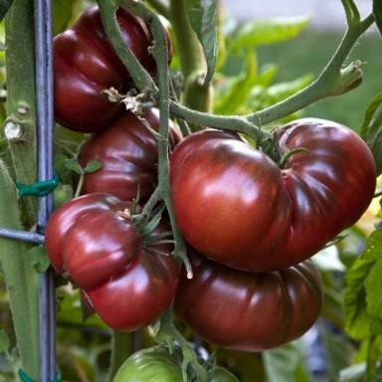
Heirloom Tomato ‘Black Krim’
Indeterminate. Violet- red, slightly flattened 4-5 inch fruits with nearly black shoulders have strong, exotic flavor that’s been described as “smoky” or “salty.” Russian variety named for the Crimean peninsula in the Black Sea. 70-90 days from transplant. OP

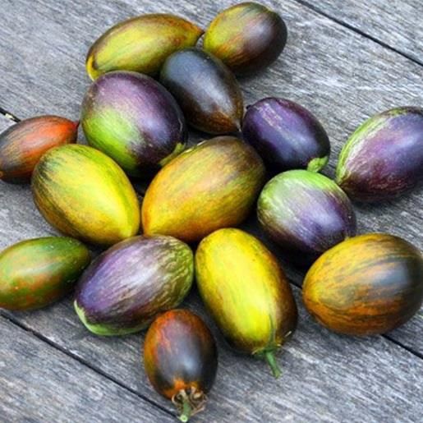
Tomato ‘Brad’s Atomic Grape’
Indeterminate. Definitely the bomb! Another winner from Brad Gates of Wild Boar Farms. Elongated large cherries in clusters with color and flavor that’s a full-blown assault on the senses. Lavender and purple stripes, turning to technicolor olive-green, red, and brown/blue stripes when fully ripe. The fruit holds well on the vine or off. Olive green interior is blushed with red when fully ripe. Crack-resistant fruit is extraordinarily sweet! 75 days from transplant. OP

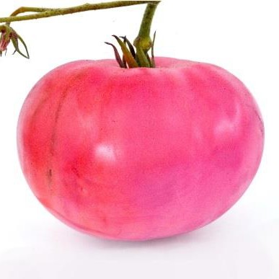
Heirloom Tomato ‘Brandywine Pink’
Indeterminate. A pink-colored beefsteak with excellent flavor that perfectly balances high sugar and high acid. Potato leaf plants produce good yields of slightly irregular, meaty, juicy 1-pound fruits. 80-90 days from transplant. OP

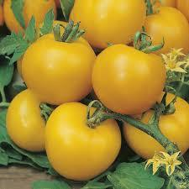
Tomato ‘Dixie Golden Giant’ plants are large and productive. The abundant fruits are large (one to two pounds each) and clear, lemon-yellow colored. Some fruits exhibit a pink blush on the blossom end. It has a nice, juicy, sweet fruity flavor. 85 days, indeterminate

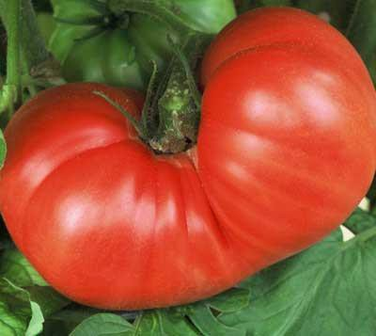
Tomato ‘Goliath’ Appropriately named, this variety bears giant fruit. Dark pink, solid tomatoes are ribbed, have few seeds, and are very sweet yet have an acid component, making for really good flavor. Most fruit is in the 1 to 2 lb. range, but it is not unusual for tomatoes to become a mammoth 3 lbs. Heirloom variety grown since the late 1800's. indeterminate. 85 days.

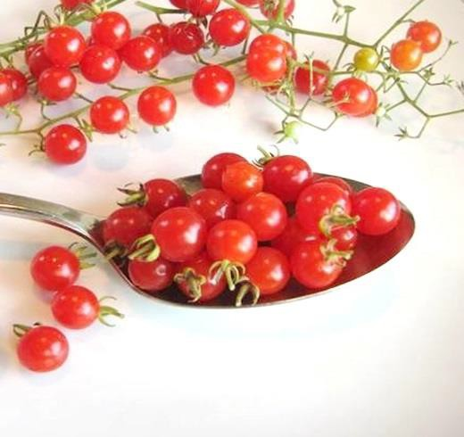
Tomato ‘Spoon’ Indeterminate. Probably the world’s smallest tomato! All the flavor of a beefsteak is crammed into fruit the size of a pea. Twenty will fit in a teaspoon, they are very ornamental, and they taste great. Vigorous vines will scramble up a trellis and cover your front porch, or you can prune them to a bushy shape. Either way, they'll produce millions of tiny pea-sized fruits. 72 days.

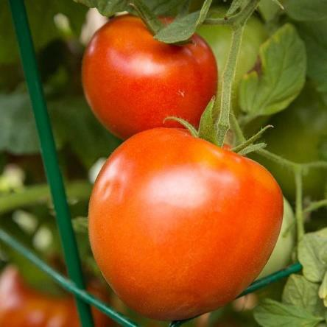
Tomato ‘Super Fantastic’ Indeterminate. Produces very high yields of solid, meaty, smooth-skinned 10 0z. fruit all summer.
Blossoms and fruit develop progressively, and the harvest lasts several months. One of the BEST tomatoes. Full sun. 70 days to maturity.

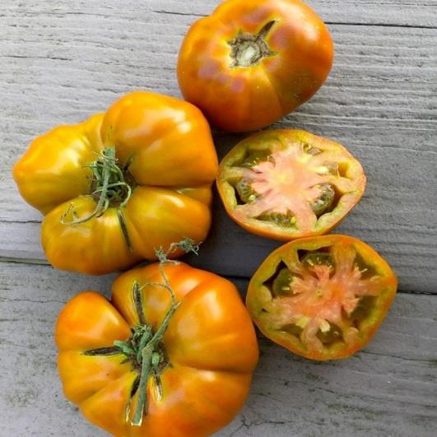
Heirloom Tomato ‘Thorburn’s Terra Cotta’ Indeterminate. Incredible flavor, color and history! Introduced in 1893 by James Thorburn of New York, this sensational beefsteak tomato has honey-brown skin, orange-pink flesh, and green seed mass. Adds wonderful flavor to salads, sauces or any meal; also a wonderful slicer. As a cooker it will yield a pumpkin-orange sauce with a floral aroma.
Produces heavily during mid-season and then drops off quickly once cool weather sets in. Full sun. 75 days.

Heirloom Tomato ‘Virginia Sweets’
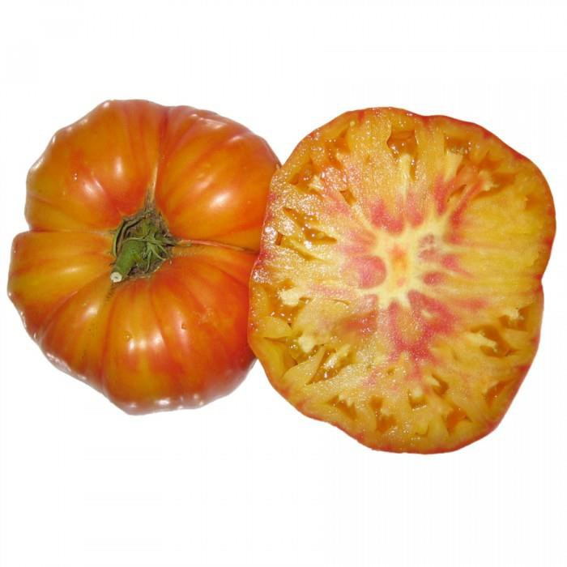
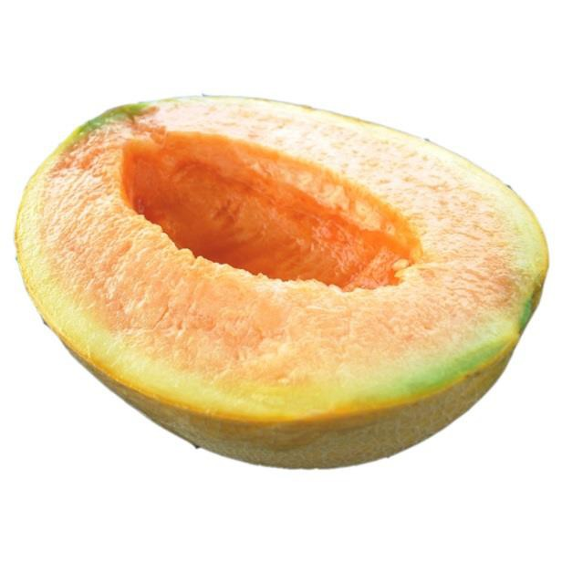
Indeterminate. This heirloom variety is simply one of the best tasting, best producing gold-red bicolors. The tomatoes are stunningly beautiful and enormous, weighing at least 1 pound each. Golden yellow beefsteaks are colored with red stripes that turn into a ruby blush on top of the golden fruit. Flavor is sweet and rich, and harvests are abundant. Full sun. 80 days.

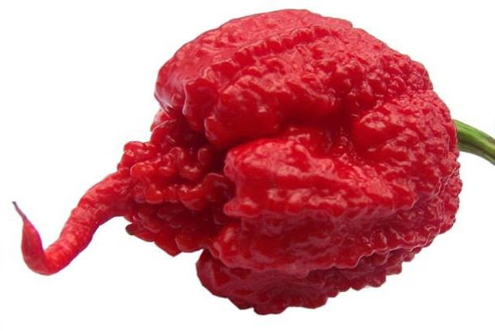
Hot Pepper ‘Carolina Reaper’
Carolina Reaper has ascended to the top of the Scoville Heat Unit scale as the hottest pepper in the world. The original cross was between a Ghost pepper (Bhut Jolokia) and a red habanero and is named ‘Reaper’ due to the shape of its tail. For those who love hot peppers, Carolina Reaper is a must– for those less adventurous, they make a great conversation piece.

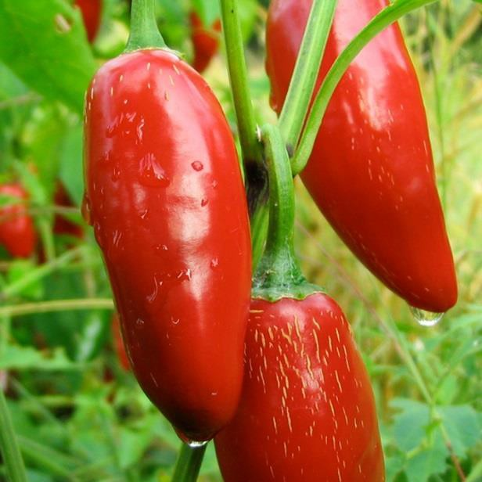
Hot Pepper ‘Sriracha’
Attractive, large, 5″ x 1-1/4″, jalapeño-type fruits are firm and uniform with shiny, smooth skin and thick walls. Ripens to red. Flavor is mildly hot, but not overpowering. Perfect for slicing, roasting and pickling. Peppers have a long shelf life. 65-70 days. With the ripening comes a kick up in heat (an increase in capsaicin) to the upper end of the jalapeños range (2,500 to 8,000 Scoville heat units).

