OSU Vegetable Farm Garlic Variety Trial 2019
MATERIALS AND METHODS
Garlic was harvested from 6/10/2019 to 7/8/2019 and then allowed to dry in a barn with the tops and roots still attached. Garlic dry down time (the time between when a plot was harvested and when it was processed) ranged from 126 to 149 days. During processing a plot was randomly selected and then all tops and roots were removed from all of the bulbs. Each bulb was subjected to a quick squeeze test to determine if the bulb was good or bad. A “bad bulb” was one that was determined to be unmarketable after a quick squeeze test determined that more than half of cloves were bad/rotten. Good bulbs and bad bulbs were counted and then 5 good bulbs were randomly selected for further data collection. For these bulbs, bulb brooming was noted and then each bulb was individually weighed and broken up into cloves. For each bulb, plantable cloves were counted, plantable cloves were weighed, unplantable cloves were weighed, and then two plantable cloves were randomly selected and peeled to look for evidence of mite damage. Additionally, it was noted if any cloves were rotten, bad, green, sprouting, shriveled, or had bad spots. Examples of some of these conditions are shown in Figure 1.

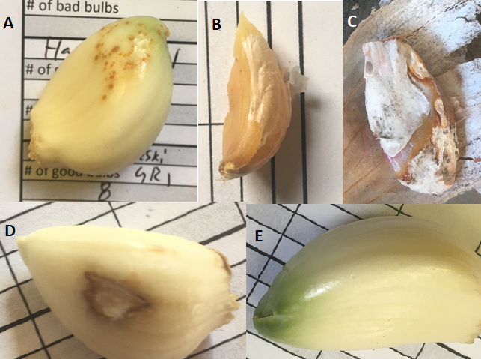
Figure 1: Some examples of garlic clove problems. A) Garlic clove exhibiting heavy mite damage. B) Bad garlic clove. C) Rotten garlic clove. D) Garlic clove exhibiting a bad spot. E) Green garlic clove.

RESULTS
Table 1: Summary statistics for garlic grown at the OSU Vegetable Farm
Variety | Average bulb weight (oz) | Average number of plantable cloves | Average number of plantable cloves per pound | Percentage of bulbs with heavy mite damage | Percentage of bad bulbs (out of all of the bulbs harvested)
Aglio Rosso di Sulmona | 1.38 | 8.75 | 107.80 | 10.00 | 4.17
Ajo Rojo | 1.36 | 9.05 | 107.53 | 0 | 6.70
Anarres (S13 Kish 1) | 1.08 | 7.51 | 113.99 | 16.25 | 0
Arpakalen (W6 24414) | 1.16 | 4.78 | 71.25 | 0 | 22.50
Arsia (S10 Kras 3) | 0.92 | 5.70 | 115.10 | 5.00 | 0
Asian Tempest | 1.34 | 6.84 | 81.76 | 11.25 | 12.50
Basque Turban | 1.89 | 8.55 | 74.13 | 0 | 0
Beekeepers' Sicilian | 1.60 | 6.30 | 64.87 | 10.00 | 0
Belarus | 1.52 | 7.55 | 79.97 | 0 | 0
Blanchard | 1.50 | 7.90 | 90.75 | 0 | 0
Brown Rose | 1.68 | 6.10 | 58.92 | 0 | 4.17
Chet's Italian Red | 1.83 | 9.85 | 87.35 | 15.00 | 0
Chimyan (Z 59 or W6 46684) | 1.71 | 5.60 | 52.79 | 5.00 | 0
Creole Red | 1.27 | 6.25 | 77.30 | 5.00 | 4.17
Cusco | 0.97 | 6.35 | 108.15 | 0 | 0
Donostia Red | 1.33 | 9.00 | 109.31 | 10.00 | 5.90
Dunganski | 2.24 | 8.25 | 59.82 | 0 | 0
German White | 1.91 | 5.95 | 49.95 | 0 | 0
Greek | 0.62 | 7.32 | 192.18 | 0 | 20.24
Hadrut | 1.18 | 4.89 | 75.85 | 10.00 | 4.17
Jade Rose | 1.13 | 7.30 | 104.58 | 0 | 0
Jaxartes (W6 48169) | 1.55 | 5.45 | 56.58 | 5.00 | 4.17
Khabar | 2.28 | 6.45 | 45.45 | 0 | 12.5
Killarney Red | 0.93 | 6.65 | 113.87 | 0 | 0
Kishlyk (Z 88 or W6 46687) | 1.26 | 9.20 | 117.91 | 5.00 | 2.78
Metechi | 1.41 | 5.26 | 64.84 | 5.00 | 5.00
Mt. Hood | 1.73 | 5.88 | 54.99 | 0 | 5.00
Mt. St. Helens | 1.80 | 8.75 | 77.75 | 0 | 6.25
Music | 1.47 | 5.75 | 69.74 | 5.00 | 0
Navistar (S11 Ivan 1) | 0.53 | 5.70 | 172.47 | 0 | 4.17
Nepal (W6 2308) | 0.83 | 8.73 | 175.25 | 0 | 4.17
Northern White | 1.98 | 6.25 | 51.19 | 0 | 0
Novo Troitzk (W6 26171) | 1.04 | 6.85 | 106.72 | 0 | 9.17
Ozodlyk (S13/14 Kishlyk 1) | 1.52 | 7.50 | 84.27 | 6.25 | 14.88
Pavonis (S10 Kras 4) | 0.92 | 6.30 | 110.67 | 0 | 4.17
Polish White | 2.12 | 8.35 | 62.78 | 10.00 | 7.67
Pyongyang | 1.33 | 6.10 | 73.42 | 0 | 4.17
Russian Redstreak | 1.15 | 4.10 | 59.23 | 0 | 4.17
Sakura | 1.07 | 4.60 | 69.61 | 0 | 4.17
Shatili | 1.24 | 7.45 | 97.74 | 0 | 0
Shavat (W6 48168) | 0.52 | 4.15 | 136.97 | 5.00 | 0
Shvelisi | 0.78 | 6.30 | 139.73 | 0 | 0
Siberian | 1.89 | 6.55 | 55.57 | 0 | 4.17
Silver Rose | 1.22 | 9.15 | 121.46 | 0 | 3.13
Siskiyou Purple | 2.47 | 9.90 | 64.88 | 10.00 | 0
Sural | 1.48 | 5.75 | 63.48 | 0 | 4.17
Vekak | 1.59 | 8.55 | 88.40 | 0 | 0
Verchnyava Mcara (PI 540356) | 1.00 | 7.20 | 116.73 | 0 | 0
Variety | Average Bulb Weight (grams) | Average number of plantable cloves | Average number of plantable cloves per pound | Average percentage of bulbs with heavy mite damage | Average percentage of bad bulbs (out of all of the bulbs harvested)
White Turban | 67.73 | 9.54 | 63.95 | 0 | 0
Wildfire W6 1885 | 1.27 | 7.45 | 94.75 | 0 | 0
PI 38222 Veleski | 0.88 | 10.87 | 197.35 | 6.67 | 2.78
PI 38333 Blateck 1 | 0.90 | 9.27 | 166.76 | 0 | 9.09
PI 383819 Pristinki | 1.12 | 11.47 | 164.09 | 0 | 0
PI 383820 prizenski | 0.51 | 7.13 | 226.20 | 0 | 3.70
PI 383824 Lokalen | 0.41 | 6.87 | 274.53 | 0 | 3.33
PI 385823 Ivankaisia | 0.88 | 9.13 | 169.44 | 13.33 | 0
PI 493097 11 | 0.90 | 6.00 | 107.00 | 0 | 0
PI 493099 47 | 1.03 | 4.07 | 64.18 | 0 | 4.17
PI 493107 91 | 0.50 | 9.33 | 296.22 | 0 | 0
PI 493110 126 | 1.93 | 5.87 | 49.32 | 6.67 | 29.17
PI 493112 135 | 0.63 | 7.73 | 195.16 | 6.67 | 0
PI 493114 Cinsky | 0.63 | 9.87 | 252.88 | 0 | 0
PI 493116 174 | 1.01 | 6.67 | 105.93 | 0 | 0
PI 493117 TyBet 1814 | 0.70 | 7.20 | 166.36 | 0 | 19.17
PI 497948 | 0.52 | 7.13 | 225.48 | 0 | 5.56
PI 497951 Kisswani | 0.57 | 7.80 | 219.33 | 0 | 0
PI 515974 Oswego White | 0.75 | 6.27 | 141.21 | 6.67 | 8.47
PI 540315 82 | 1.53 | 11.33 | 118.91 | 0 | 0
PI 540319 B81 | 1.74 | 6.33 | 58.50 | 0 | 0
PI 540320 R87 | 0.97 | 8.20 | 145.42 | 6.67 | 16. 70
PI 5403214 Yaroodi | 0.98 | 11.80 | 196.51 | 0 | 4.17
PI 540336 Seversky Palicak | 1.46 | 7.27 | 79.79 | 0 | 8.33
PI 540340 Jampolski | 0.86 | 5.00 | 94.79 | 0 | 0
PI 540344 501-85-76 | 0.98 | 6.50 | 106.13 | 8.33 | 38.89
PI 540364 Besancon 7340 | 1.31 | 5.87 | 71.84 | 6.67 | 0
PI 540375 Silverskin | 1.21 | 10.87 | 144.19 | 0 | 13.26
PI 540376 A860616-03 | 0.83 | 7.53 | 147.76 | 0 | 11.57
PI 540377 A860616-05 | 0.95 | 8.53 | 155.79 | 0 | 31.94
PI 540378 Woodstock | 0.53 | 5.13 | 158.32 | 0 | 3.03
PI 540379 870727 | 1.41 | 9.27 | 105.21 | 0 | 4.17
PI 541557 850904-32 | 0.43 | 7.27 | 299.96 | 0 | 15.08
PI 543049 WKP 88 19 | 1.17 | 13.60 | 185.21 | 0 | 8.33
PI 576914 U085 | 1.45 | 4.47 | 51.03 | 0 | 0
PI 615420 Sybirsky | 1.71 | 5.73 | 54.29 | 0 | 12.50
PI 615434 A1078 | 1.18 | 12.60 | 175.42 | 0 | 0
W6 10472 S92-5 | 0.64 | 10.73 | 270.74 | 0 | 4.17
W6 10473 E92-16 | 0.73 | 10.60 | 241.50 | 0 | 0
W6 10717 BE 4215 | 0.84 | 7.53 | 141.11 | 0 | 4.76
W6 12820 850904-42 | 2.03 | 8.00 | 62.97 | 13.33 | 12.50
W6 14858 | 1.45 | 5.87 | 66.78 | 0 | 9.72
W6 17281 | 1.44 | 6.67 | 74.54 | 0 | 5.56
W6 1861 Duganski | 1.18 | 7.13 | 96.81 | 0 | 0
W6 187275 | 0.82 | 8.32 | 164.41 | 13.33 | 58.89
W6 18729-7 | 2.66 | 10.40 | 62.73 | 13.33 | 7.04
W6 1884 Rishtanski | 0.78 | 5.47 | 115.77 | 0 | 0
W6 1903 U094 | 1.20 | 5.47 | 77.69 | 0 | 0
W6 1961 Rojo de Cuenta | 1.17 | 8.47 | 120.33 | 0 | 3.33
W6 24627 TKM 27-182 | 1.30 | 9.33 | 118.41 | 13.33 | 4.17
W6 24628 TKM 27-183 | 1.39 | 8.87 | 102.43 | 0 | 4.17
W6 26170 Akyubinski | 0.91 | 5.53 | 98.05 | 0 | 4.76
Variety | Average Bulb Weight (oz) | Average number of plantable cloves | Average number of plantable cloves per pound | Average percentage of bulbs with heavy mite damage | Average percentage of bad bulbs (out of all of the bulbs harvested)
W6 26181 Thuringer | 2.69 | 10.60 | 63.02 | 0 | 16.20
W6 26182 echo | 0.66 | 5.80 | 142.35 | 0 | 16.93
W6 26183 Gadanski | 1.31 | 7.73 | 96.57 | 0 | 0
W6 27954 TJK 2006:43 | 1.37 | 8.87 | 104.70 | 0 | 0
W6 27971 TKJ 2006:097 | 3.00 | 6.80 | 36.94 | 6.67 | 17.26
W6 35668 Darcheli | 1.04 | 7.40 | 114.43 | 0 | 0
W6 35669 FLOHA | 2.56 | 6.73 | 42.10 | 6.67 | 3.33
W6 35678 Nootka Rose | 1.28 | 10.33 | 131.01 | 28.89 | 25.00
W6 35680 Red Grain | 1.25 | 6.60 | 86.03 | 0 | 12.50
W6 35682 Rose du var | 0.83 | 6.60 | 131.53 | 20.00 | 19.44
W6 35686 Vladivastok | 1.45 | 5.27 | 65.99 | 0 | 5.56
W6 35692 DO-15 | 1.33 | 7.47 | 89.90 | 6.67 | 21.83
W6 35693 DX-90 | 1.08 | 11.60 | 172.02 | 0 | 0
W6 35694 cli-bi Dx-127 | 1.29 | 8.92 | 111.61 | 15.00 | 25.93
W6 4667 Z035-A | 1.27 | 8.67 | 112.25 | 0 | 0
W6 46670 Z001 A | 1.05 | 5.33 | 82.97 | 6.67 | 0
W6 46674 Z002 cg15 | 2.11 | 6.60 | 50.53 | 13.33 | 4.17
W6 46675 Z004 | 2.25 | 6.87 | 48.78 | 6.67 | 0
W6 46679 Z037-A | 1.98 | 5.60 | 45.10 | 0 | 0
W6 46681 Z057-A | 2.50 | 5.13 | 33.38 | 6.67 | 12.50
W6 46684 Z059-A | 2.73 | 6.13 | 36.41 | 13.33 | 0
W6 46686 Z080 | 1.54 | 8.13 | 96.83 | 6.67 | 5.56
W6 46686 Z080 | 1.60 | 8.53 | 94.92 | 6.67 | 5.56
W6 46687 Z008 | 3.06 | 11.40 | 61.02 | 13.33 | 0
W6 46688 Z108 cg6 | 2.37 | 7.53 | 51.04 | 0 | 0
W6 46689 Z108-A | 1.02 | 7.20 | 113.53 | 0 | 4.17
W6 48169 split from 27977 | 1.50 | 5.10 | 55.04 | 0 | 8.33

Additionally, I have included the data from the trial at the OSU Vegetable farm as a series of figures. These figures are for the data bulb weight, number of plantable cloves per bulb, number of plantable cloves per pound of garlic, proportion of bulbs with mite damage and proportion of bad bulbs (out of all the bulbs harvested). The “X” at the center of each bar represents the mean for that variety and the ends of the “whiskers” show the range across all the replications of that variety. So the wider the whiskers, the more variance in that variety.

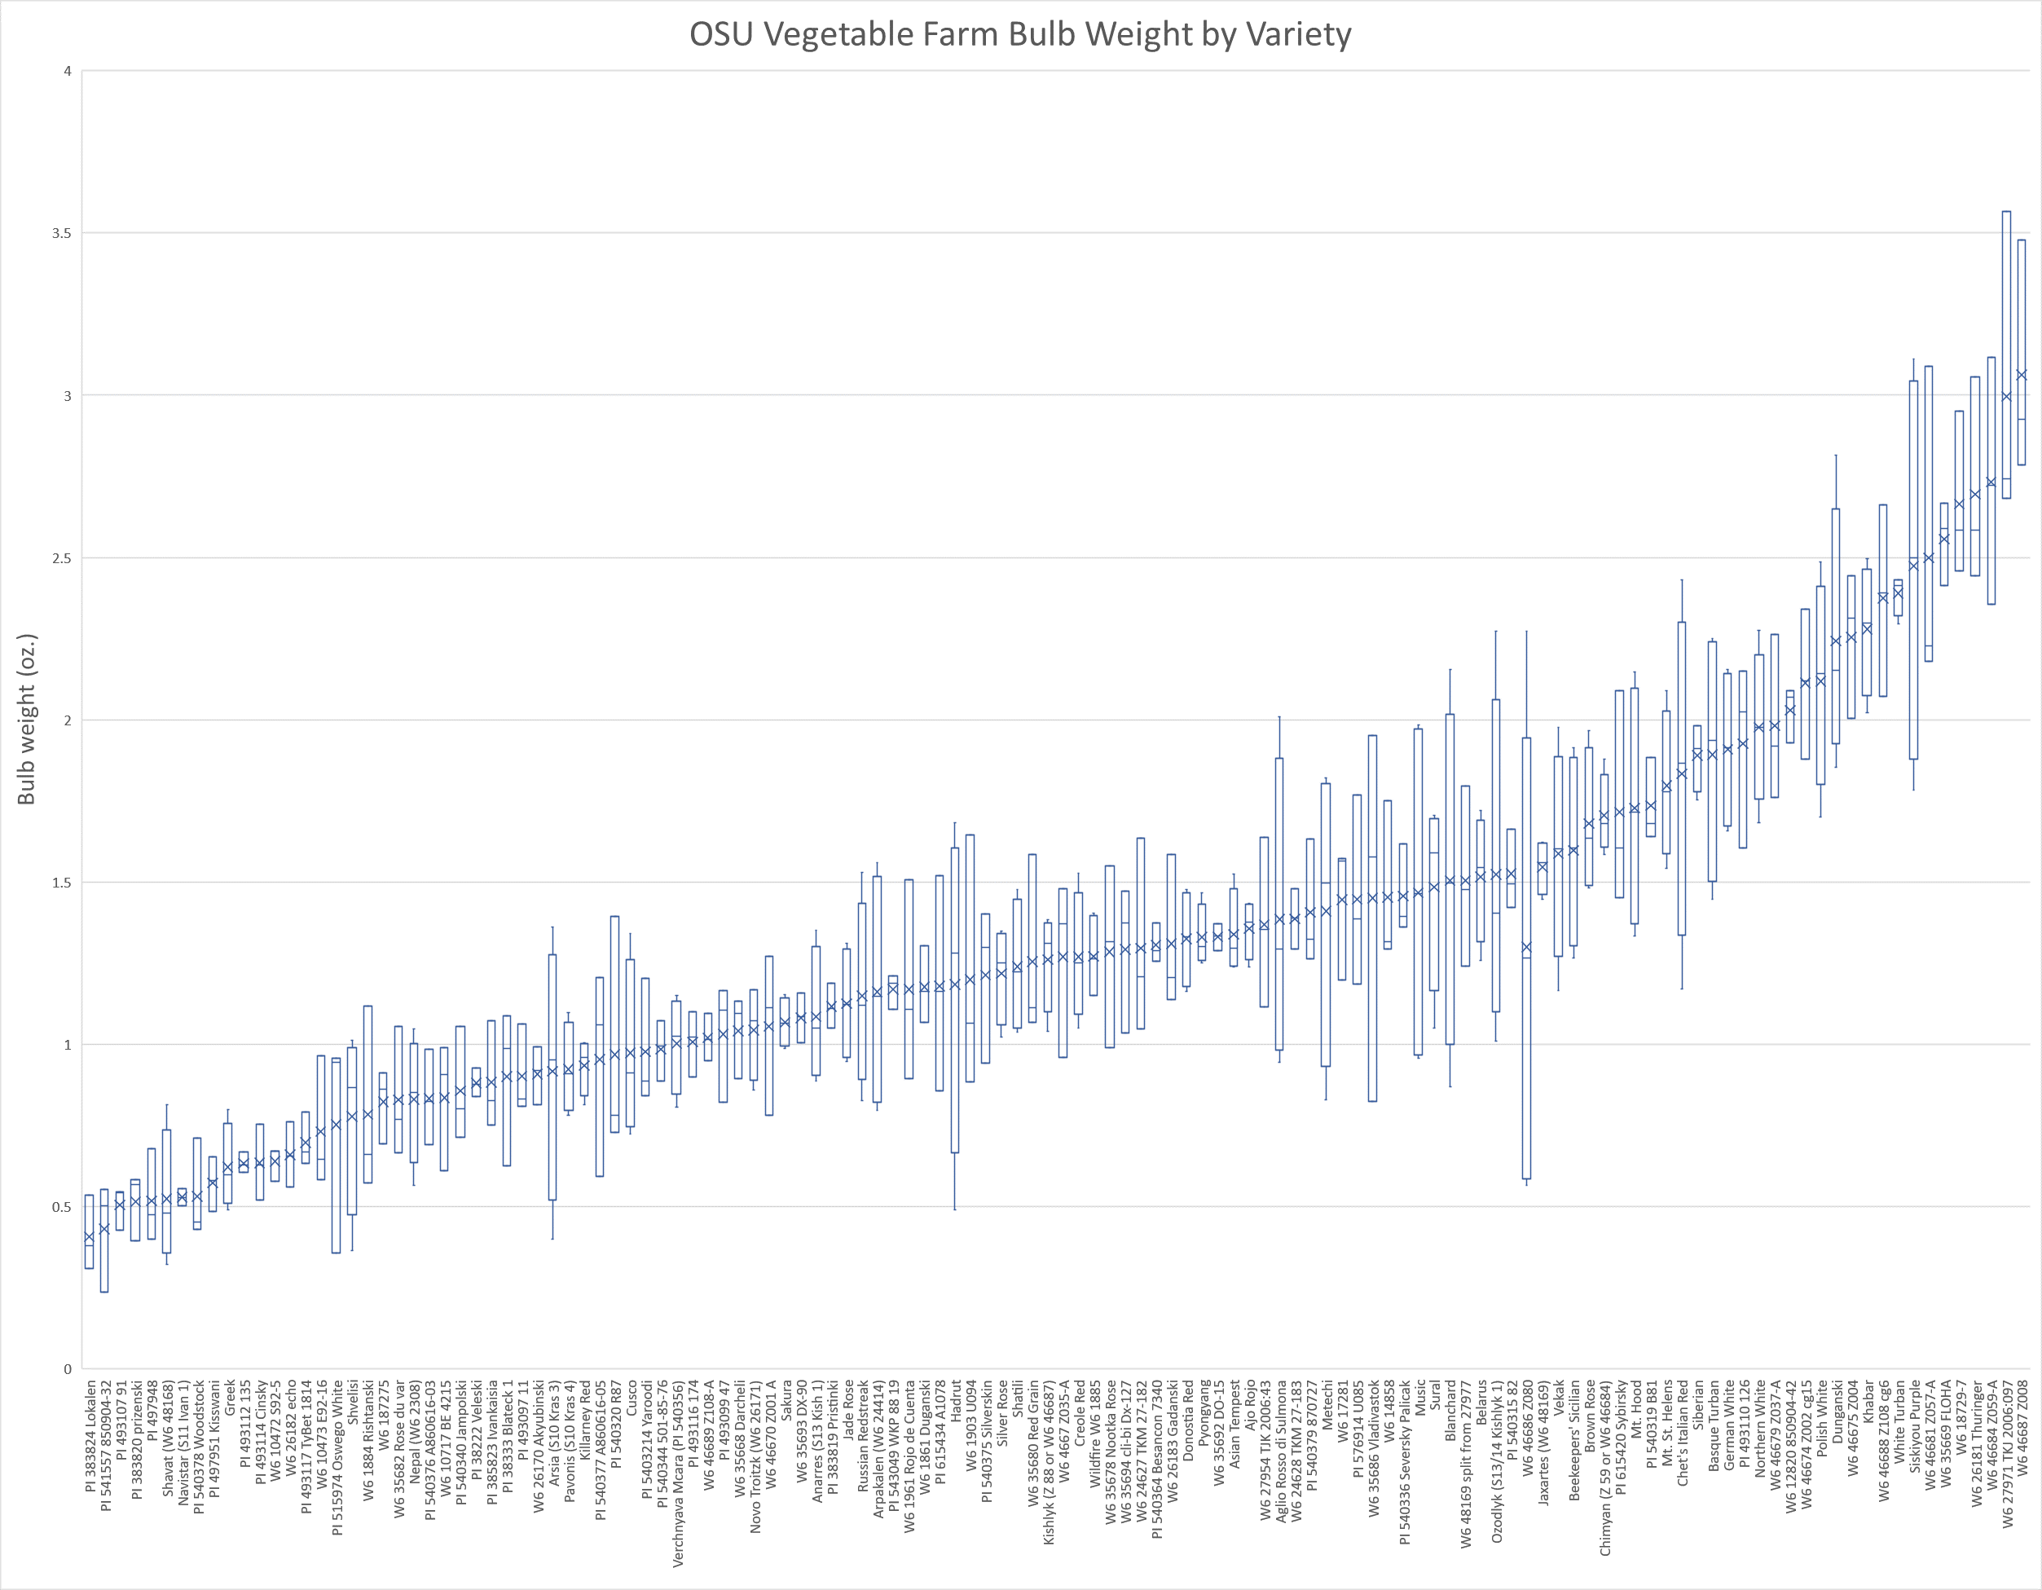
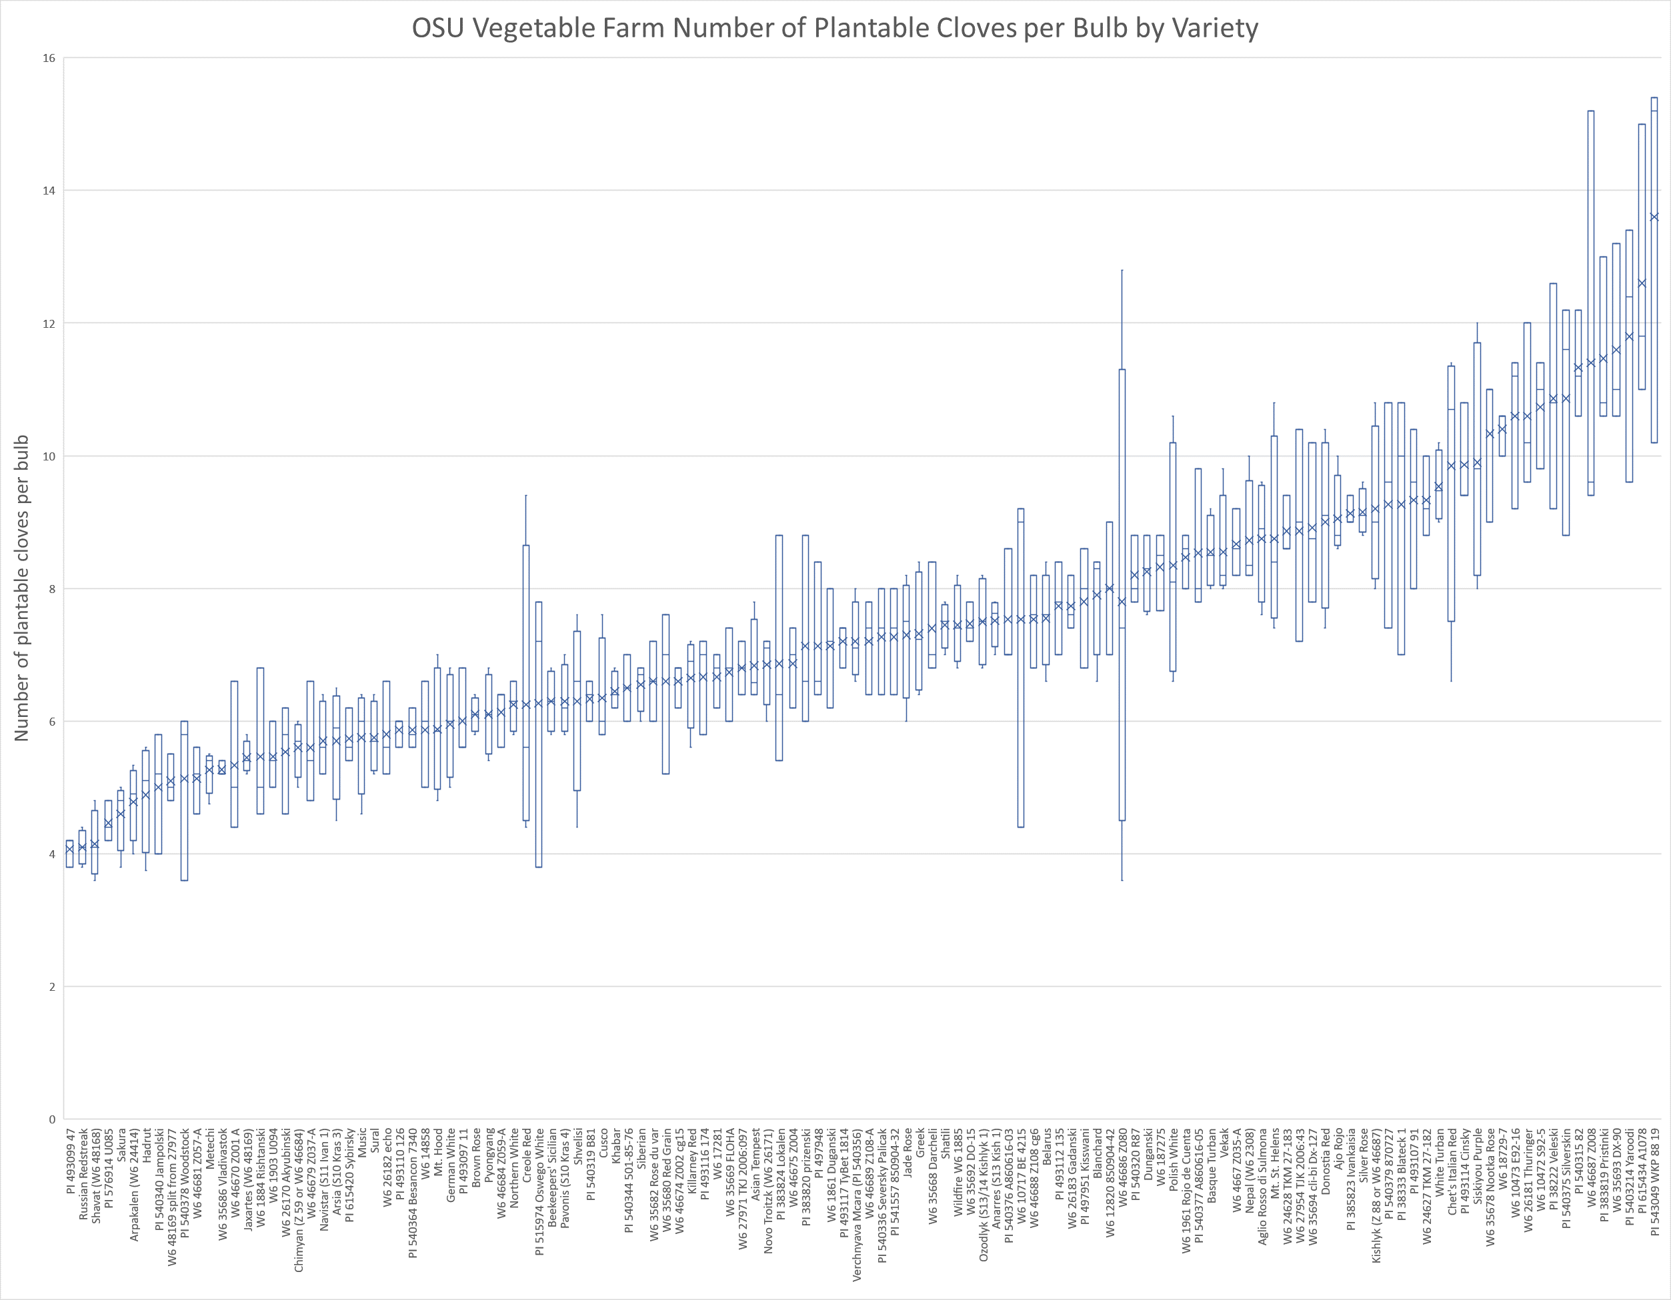
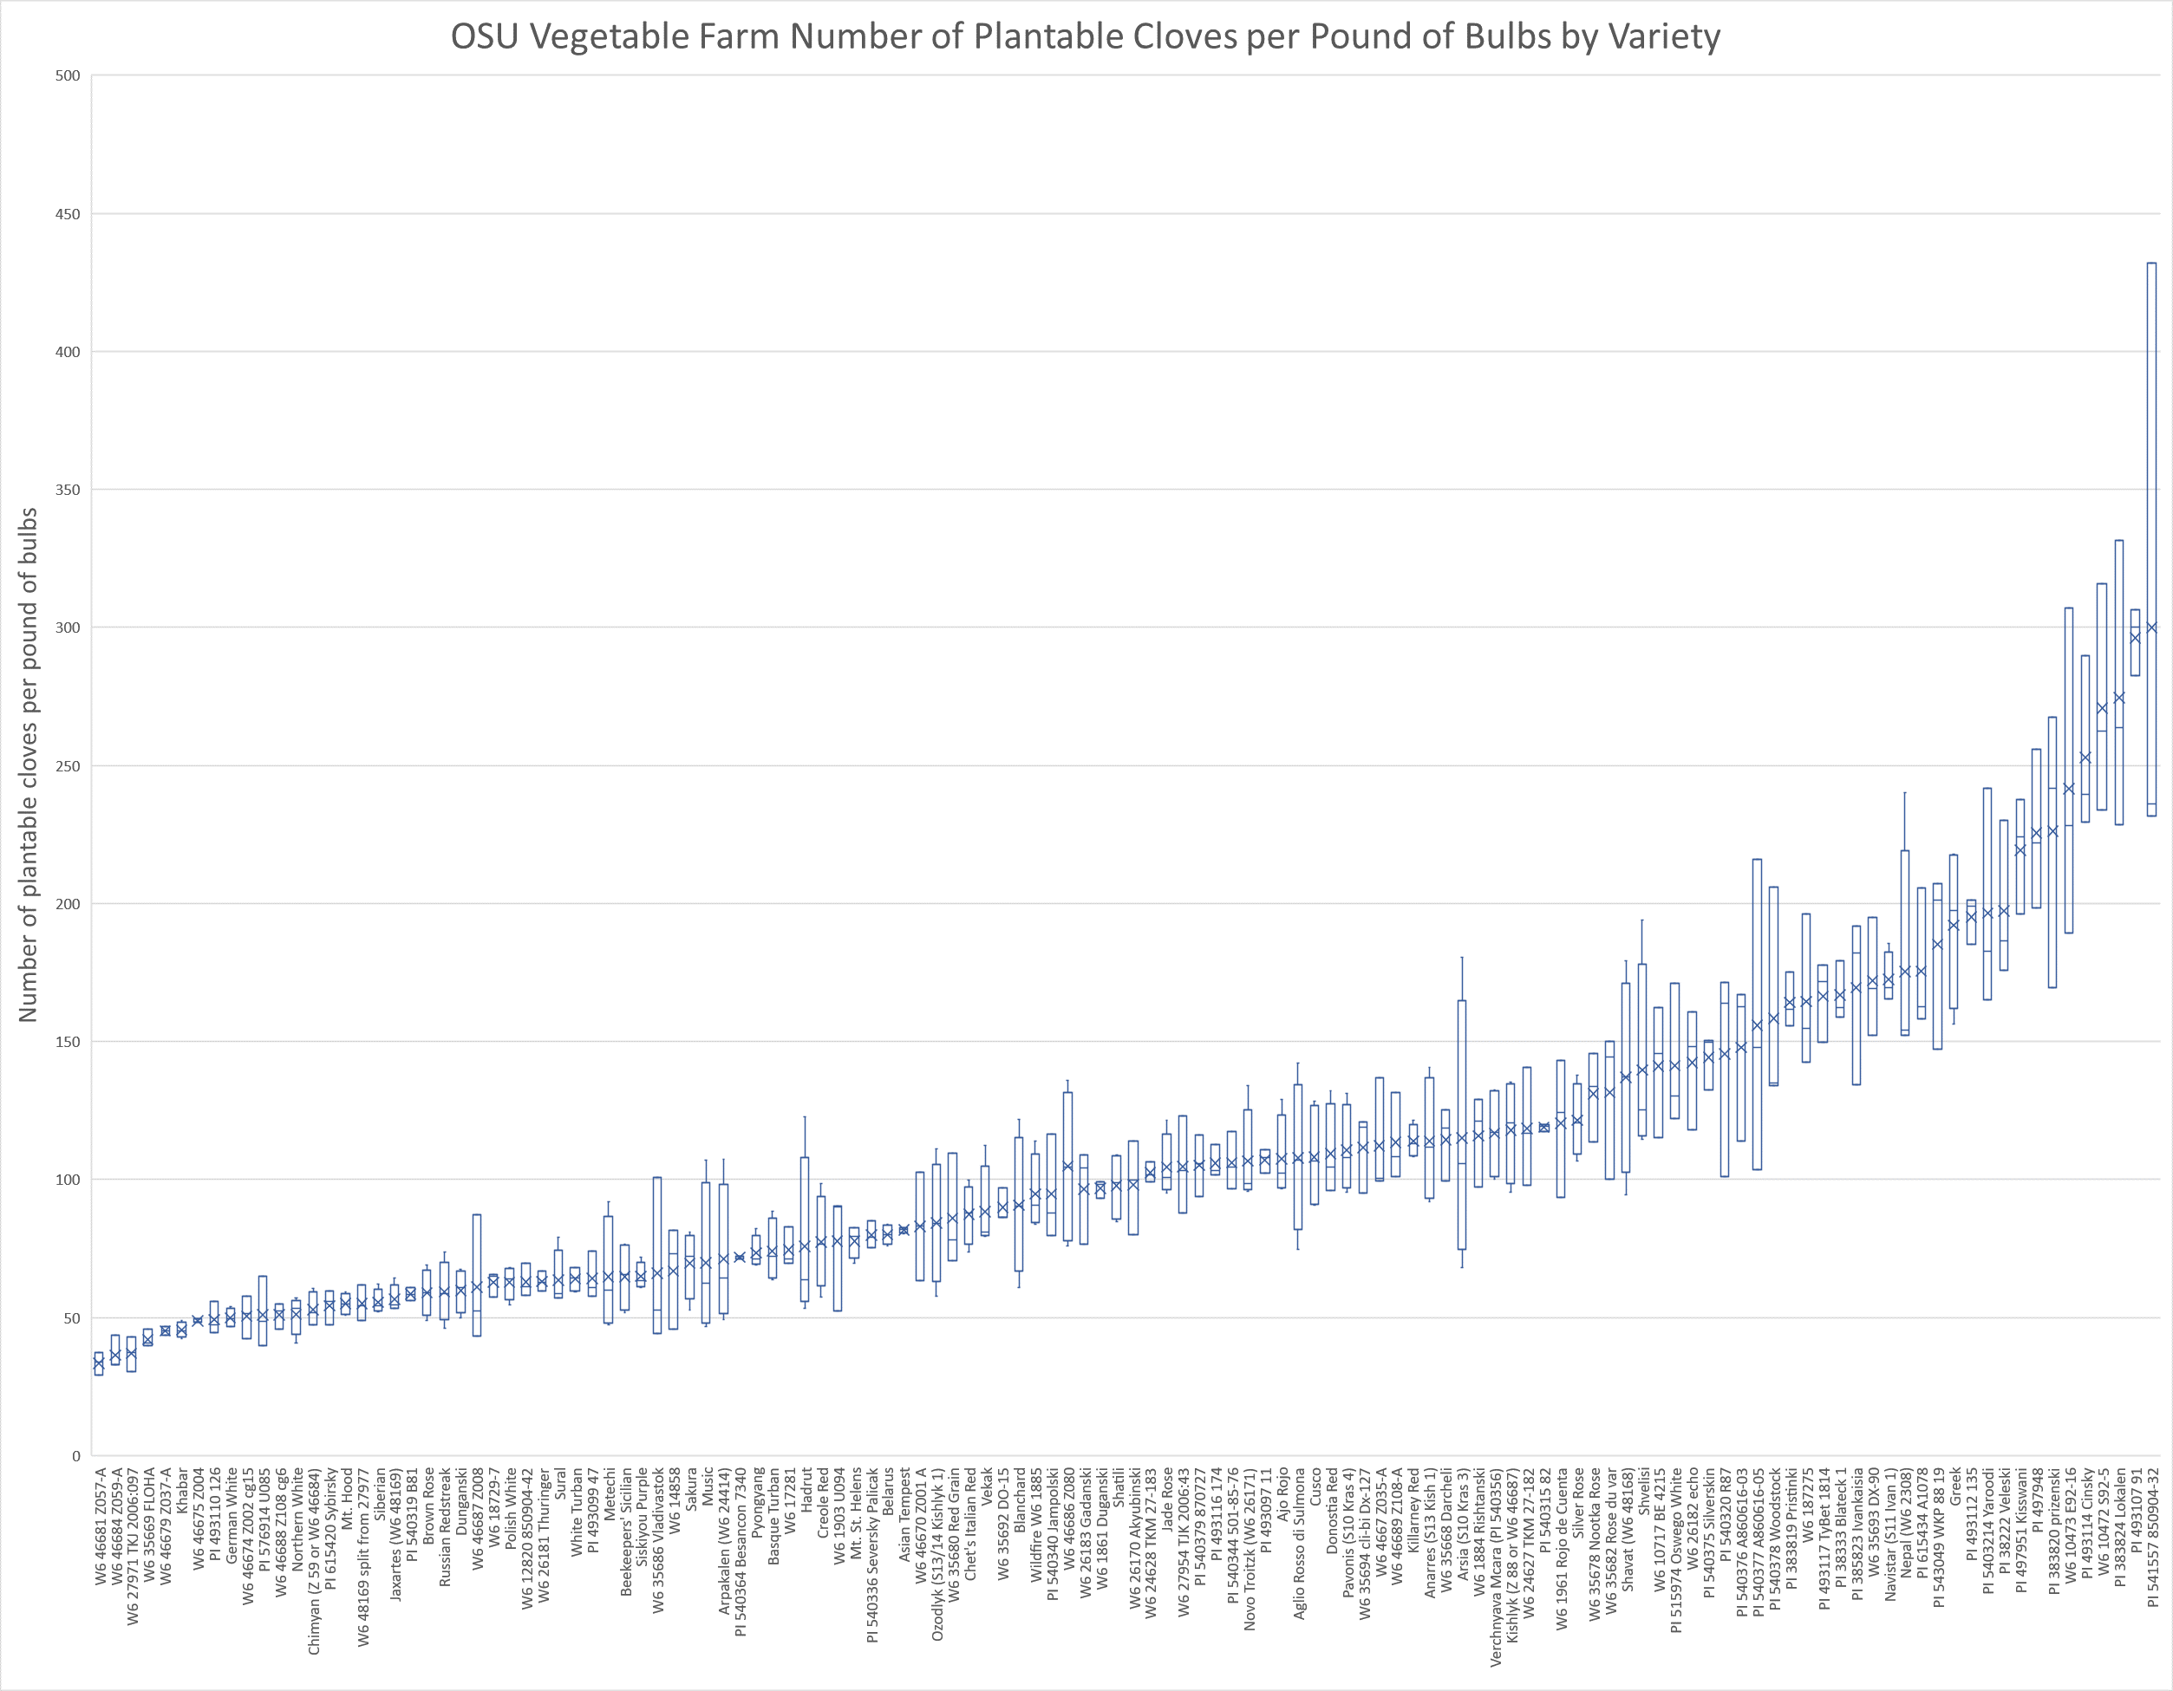
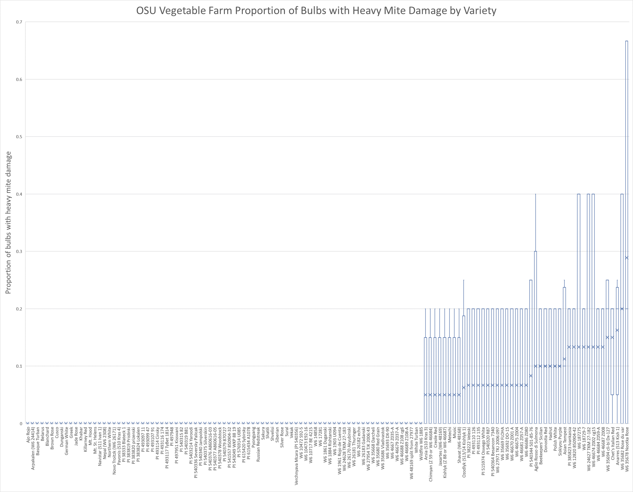
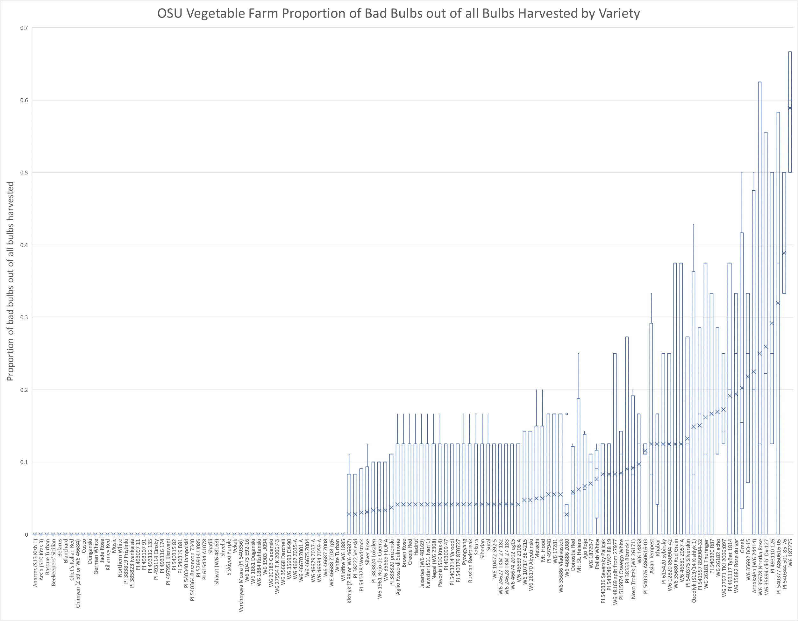
Gathering Together Farm Garlic Variety Trial 2019
METHODS AND MATERIALS
Garlic was harvested from 6/24/2019 to 7/1/2019 and then allowed to dry in a barn with the tops and roots still attached. Garlic dry down time (the time between when a plot was harvested and when it was processed) ranged from 108 to 1117 days. Garlic was processed in the same way as the OSU vegetable farm garlic. Scapes were not removed from most bulbs. Garlic was harvested when overly mature for many accessions. Keep these problems in mind when looking at this data.
Table 2: Summary statistics for garlic grown at the Gathering Together Farm
Variety | Average Bulb Weight (oz) | Average number of plantable cloves | Average number of plantable cloves per pound | Average percentage of bulbs with heavy mite damage | Average percentage of bad bulbs (out of all of the bulbs harvested)
Aglio Rosso di Sulmona | 1.01 | 7.38 | 120.87 | 6.25 | 37.08
Ajo Rojo | 1.04 | 9.28 | 144.48 | 0 | 22.50
Anarres (S13 Kish 1) | 0.77 | 5.58 | 115.44 | 6.25 | 25.83
Arpakalen (W6 24414) | 0.61 | 3.54 | 96.84 | 0 | 24.58
Arsia (S10 Kras 3) | 0.69 | 3.69 | 87.80 | 6.25 | 35.00
Asian Tempest | 1.09 | 6.38 | 93.85 | 0 | 37.92
Basque Turban | 1.40 | 9.05 | 103.43 | 0 | 6.67
Beekeepers' Sicilian | 1.59 | 6.87 | 70.81 | 5.00 | 17.90
Belarus | 0.77 | 5.73 | 120.91 | 0 | 0
Blanchard | 1.13 | 6.62 | 96.90 | 15.00 | 6.25
Brown Rose | 1.19 | 4.34 | 58.77 | 0 | 13.33
Chet's Italian Red | 1.56 | 9.98 | 104.50 | 6.67 | 58.93
Chimyan (Z 59 or W6 46684) | 1.21 | 4.11 | 55.53 | 0 | 8.33
Creole Red | 1.13 | 6.31 | 91.93 | 0 | 27.38
Cusco | 0.61 | 4.25 | 121.91 | 0 | 0
Donostia Red | 1.10 | 7.43 | 110.14 | 10.00 | 14.17
Dunganski | 1.33 | 8.26 | 104.18 | 5.00 | 22.92
German White | 1.03 | 4.75 | 74.36 | 0 | 35.00
Greek | 0.39 | 4.50 | 184.08 | 0 | 42.50
GTF (no wt.) | 1.38 | 5.31 | 62.57 | 0 | 35.42
Hadrut | 0.78 | 4.44 | 96.20 | 0 | 38.33
Jade Rose | 0.75 | 4.92 | 109.29 | 0 | 6.25
Jaxartes (W6 48169) | 1.16 | 4.52 | 65.89 | 6.25 | 39.17
Khabar | 1.32 | 5.10 | 62.20 | 0 | 18.33
Killarney Red | 0.59 | 5.77 | 164.86 | 0 | 21.25
Kishlyk (Z 88 or W6 46687) | 0.70 | 6.05 | 144.66 | 10.00 | 18.57
Metechi | 0.91 | 4.08 | 74.11 | 0 | 18.33
Mt. Hood | 1.07 | 4.40 | 65.44 | 0 | 20.83
Mt. St. Helens | 1.11 | 7.50 | 114.02 | 16.67 | 78.33
Music | 0.88 | 4.60 | 85.59 | 0 | 14.58
Navistar (S11 Ivan 1) | 0.33 | 5.18 | 259.71 | 0 | 5.00
Nepal (W6 2308) | 0.56 | 5.75 | 166.56 | 0 | 19.58
Novo Troitzk (W6 26171) | 0.62 | 6.05 | 168.64 | 0 | 23.33
Ozodlyk (S13/14 Kishlyk 1) | 1.20 | 5.76 | 78.41 | 0 | 27.50
Pavonis (S10 Kras 4) | 0.79 | 5.35 | 110.53 | 0 | 0
Polish White | 1.23 | 8.17 | 107.27 | 8.33 | 55.95
Pyongyang | 0.72 | 4.60 | 101.76 | 0 | 29.17
Russian Redstreak | 0.91 | 2.90 | 50.81 | 12.50 | 18.75
Sakura | 0.90 | 4.06 | 75.65 | 0 | 25.00
Variety | Average Bulb Weight (oz) | Average number of plantable cloves | Average number of plantable cloves per pound | Average percentage of bulbs with heavy mite damage | Average percentage of bad bulbs (out of all of the bulbs harvested)
Shatili | 0.81 | 7.00 | 155.25 | 0 | 4.17
Shavat (W6 48168) | 0.50 | 3.90 | 162.88 | 8.33 | 25.00
Shvelisi | 0.76 | 7.15 | 159.16 | 0 | 17.50
Siberian | 1.12 | 5.23 | 76.79 | 0 | 6.67
Silver Rose | 0.48 | 7.00 | 233.24 | 0 | 70.83
Siskiyou Purple | 1.44 | 9.76 | 109.48 | 0 | 32.71
Sural | 0.99 | 3.90 | 63.11 | 5.00 | 8.33
Vekak | 1.51 | 7.53 | 79.71 | 0 | 11.25
Verchnyava Mcara (PI 540356) | 0.65 | 6.88 | 169.75 | 0 | 21.67
White Turban | 1.57 | 8.75 | 89.71 | 0 | 20.00
Wildfire W6 1885 | 0.82 | 6.28 | 122.56 | 0 | 18.33

